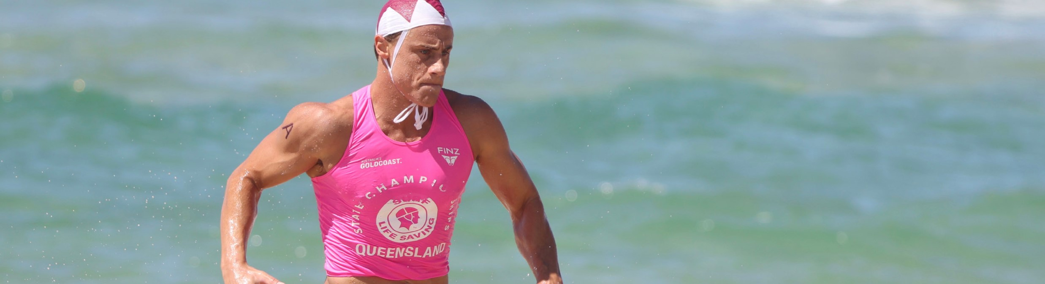
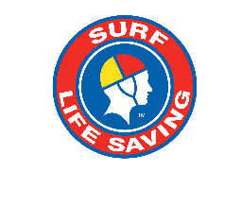
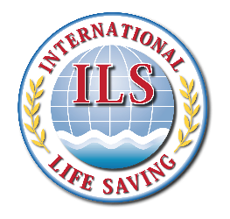


INTERCLUB MASTERS & OPEN SURF BOAT

VENUE: KURRAWA BEACH, BROADBEACH
DATE: WEDNESDAY 28th and THURSDAY 29th AUGUST, 2024

REFEREES & TECHNICAL OFFICIALS APPOINTMENTS

Notes: 1. | There will be on-line briefing by the Chief Referee for Technical Officials and Team Managers. Details and date to be advised
2. | There will be on-line briefings by the Safety Officer for Technical Officials. Details and date to be advised.

POSITION | OFFICIALS
CHIEF REFEREE | Tony HAVEN (AUS-S)
DEPUTY CHIEF REFEREES | Charles MELLOY (AUS-S); Peter VAN DEUREN (AUS-S)
REFEREES STEWARDS - REGISTER | Craig VAN ROOYEN (RSA); Cynthia BARENDS (RSA) & Patricia ALLUM (AUS-S)
EVENT MANAGEMENT COMMITTEE | Dave THOMPSON (AUS-S) - Chairman; Jelle MEINTSMA (RSA) - Secretary; Greg ALLUM (AUS-S) & Wim NUYENS (BEL)
LOC EVENT MANAGER | Ken BIRD (LOC)
JURY OF APPEAL PANEL | Mike MARTIN (AUS-S) – Convenor; Kevin COUPER (AUS-S); Jean COUPER (AUS-S); John GALEA (AUS-S); John CUSTANCE (AUS-S); Ross BARTLETT (AUS-S); Neil MORARTY (AUS-S)
EMERGENCY / SAFETY | LOC APPOINTMENT
MEDICAL/FIRST AID | LOC APPOINTMENT
HEAD SCORER | Thecla HAVEN (AUS-S)
FIRST AID | LOC APPOINTMENT
RADIO OFFICER | Sonya VAN KEIMPEMA (AUS-S)
SCRUTINEER | Kim HOLDOM (AUS-S); Keith ABRAHAM (AUS-S); Michael NOUGHER (AUS-S)
COMMENTATORS PANEL | John HAMREY (AUS-S) – Convenor; Bruce BEVAN (AUS-S); Nathan McCULLUM (AUS-S), Rod COSTA (AUS-S), Andy HOBAN (AUS-S); Karen COSTA (AUS-S)
PRESENTATION TEAM | LOC APPOINTMENT
SECTIONAL REFEREE | David HARGREAVES (AUS-S) & Mick LANG (AUS-S)
DEPUTY SECTIONAL REFEREE | Tamara BRAWN (AUS-S) & Benny LARSON (NZL)
COURSE SUPERVISOR | Ashley CARDIFF (AUS-S) & John MASTER (AUS-S)
CHIEF JUDGE | Diane SMITH (AUS-S)
STATISTICIAN | Sandra SLATTERY (AUS-S)
MARSHALLS | Susan CHARMAN (AUS-S); Michelle HAWKINS (AUS-S); David EADES (AUS-S); Leonie NEWEY (AUS-S); Lynda WOODS (AUS-S)
STARTERS | John CASSIDY (AUS-S); Glen JONES (NZL); John KING (AUS-S); Dennis O’TOOLE (AUS-S); Scott TANNAHILL (AUS-S); Craig BURCHILL (AUS-S)
CHECK STARTERS | Melinda AKEHURST (AUS-S); Andrew BLOXAM (AUS-A); Margaret CARGNONI (AUS-S); Peter ROGERS (AUS-S)
RESULTS | Janine FAHEY (AUS-S); Fabrico Frazatto SANTOS ( BRA); Michelle NEWTON (NZL)
VIDEO JUDGE | Michael NOUGHER (AUS-S)
RECORDER | Donna HARGREAVES (AUS-S); Susan HUNT (AUS-S); Carole JOHNSTONE (AUS-S); Gail KING (AUS-S); Judith MELLOY (AUS-S)
COMPETITORS LIAISON | Jennifer DRURY (AUS-S); Jeff HEWITT (AUS-S); Phil LYTHAM (AUS-S); John ROBINSON (AUS-S)
COURSE JUDGES | Denis ABLE (AUS-S); David BEAKE (AUS-S); John FAHEY (AUS-S); Greg JOHNSTON (AUS-S); Douglas SIMPSON (AUS-S); Peter STEENSON (AUS-S); Stephen WAY (AUS-S); Peter HALL (AUS-S); Peter HAMMERSLEY (AUS-S); Mick CROWLE (AUS-S); Marcello GARAY (AUS-S); Gary PETTIGROVE (AUS-S)
FINISH JUDGES | John DUNN (AUS-S); Phillip HAMMOND (AUS-S); Megan KESSEY (AUS-S); Stuart MANSON (AUS-S); Robert McCUE (AUS-S); Natasha PERKINS (NZL); Phil SMITH (AUS-S); Gary STAPLES (AUS-S); George PRESCOTT (AUS-S); Terry STEDMAN (AUS-S); Ken LAURENCE (AUS-S); Michael PARKES (AUS-S)
BOAT COORDINATOR | Tony CARLE (AUS-S)
IRB DRIVERS | Richard CASTLE (GBR-S); Niall DAVID (GBR-S); Paul EDWARDS (GBR-S); Ian JAMES (GBR-S); Alex PARKER (GBR-S); Mini FRY (GBR-S); Dougal FORSYTH (AUS-S); David LYONS (AUS-S)

The appointments are subject to change. The Chief Referee and/or ILS Sport Commission may change the official’s allocation at their sole discretion to meet the exigencies of the championship.

